MSIS 638

Case 4.4b

Jia Liang Ma

1. Search the term “expected utility”. The following video is a good starting point.

<https://www.youtube.com/watch?v=IFnoaLSXKGg&ab_channel=AdamG>

Explain, in your own words, what expected utility is?

Expected utility is an approach can summarize the utility inside an aggregate or probability problem. Evaluating the case by using the utility function. To determine the optimal solution based on comparing the expected utility inside the probabilities rather than choosing the expected value as the only parameter.

1. How can you use expected utility instead of expected payoff in decision-making?

For expected payoff, if we only took the expected value as reference may cause unprecise or sub-optimal outcomes. For example, if a case referenced the solution from the expected probability, then even the choice with better outcome, sometimes it cannot reflect the risk level or true value of the essence in this case. For expected utility, it will take utility into account so that it can show the multi-domestic dimensions of factors by the utility probability. Expected utility can help making the decision with a closer consideration and more accurate to users’ demand. In this way, this approach can better deal with uncertainty.

1. What are the three approaches a person might have towards risk? The following video is useful:

<https://www.youtube.com/watch?v=cSZvSy4Vopc&ab_channel=IrisFranz>

According to the video “Expected utility”, there are three approaches, called risk aversion, risk neutral and risk loving. Take lottery as an example, if a person who like to win the prize with half of the chance losing the money, then he or she is risk loving. If the person who will save the money for good without betting half of the chance, then he or she is risk aversion. For the last one, risk neutral means the chance of acting or not is half and half.

There is also a chance that the one will be risk loving and risk aversion at the same time which depends on the situation. (ex, being averse when buying insurance, and being averse when buying lottery.)

1. Now consider the Fantasia Restaurant payoff table discussed in the text. We know that EVPI = $52,000. Assume the Fantasia restaurant can obtain perfect information from a marketing firm at a price of $45,000. Using the mathematical expectation approach, Fantasia restaurant should accept the offer. Given that rejecting the offer is slightly risky (demand may turn out to be low!), devise a *risk loving* utility function that will reject the offer. Remember to show your calculations.

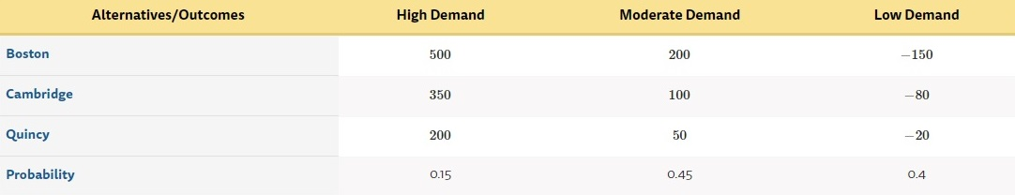

EVPI = $52,000

Original function: EPPI (157) - BEV (105) = EVPI (52)

Also, opportunities loss is 0 in this case, so 52 - 0 = 0

Marketing offer (EVPI) = $45,000

Risk loving function:

C, Q ≥ B

U(x) = x2

Cambridge = EPPI (157) - BEV (65.5) =EVPI (91.5)

Quincy = EPPI (157) - BEV (47.5) =EVPI (110.5)

B 522 = 2,704 ≤ 4,500

C 91.52 = 8,372.25

Q 110.52 = 12,210.25

Also, after taking the situation of lower demand in the future into account, the EVPI of the risk loving is still 1.66 times lower than the marketing offer. Thus, the restaurant can reject this offer as they gain the lower price for EVPI in this scenario.